#What'sInMyCity
Analysis Document Phase 3

Group 7



Physical Data Model

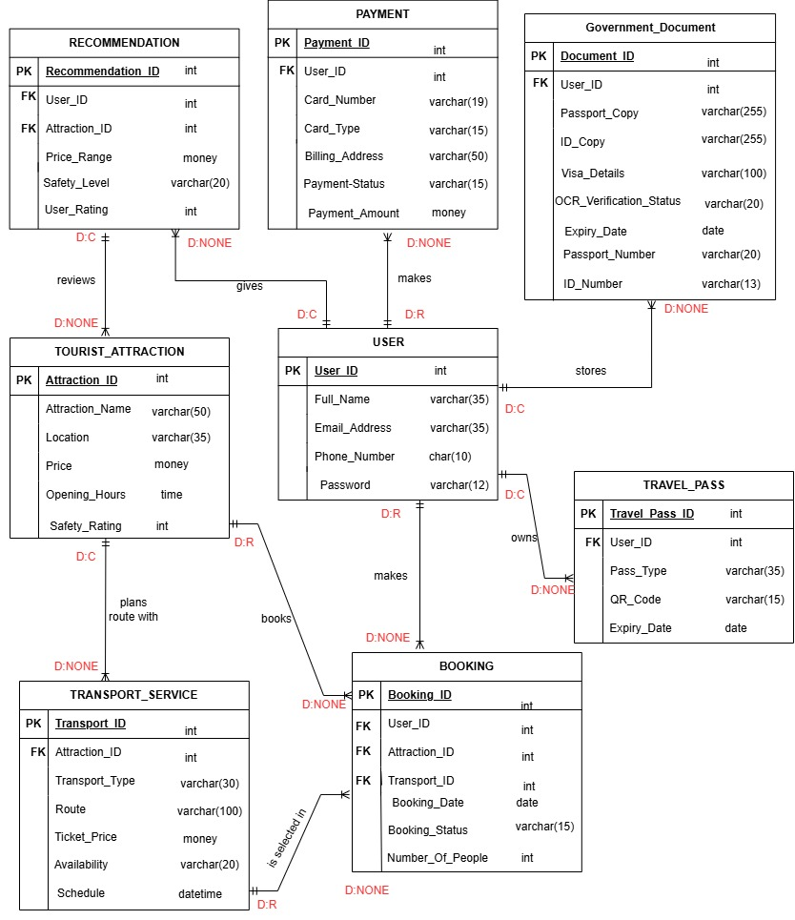

Physical Process Models

Create Tourist Booking

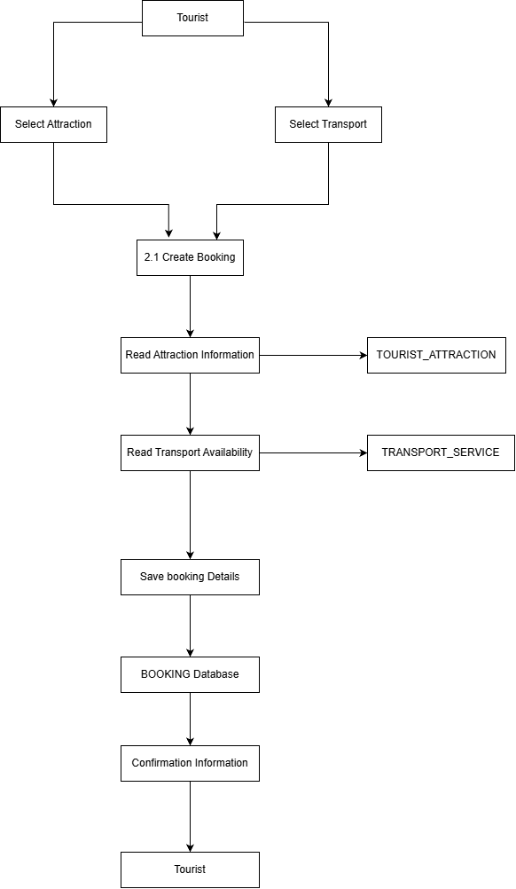

Process Payments
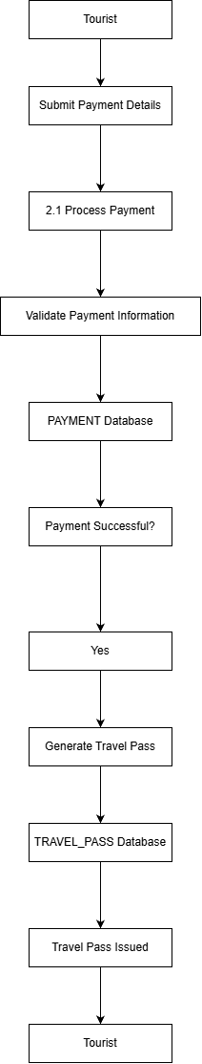

Maintain Transport Services
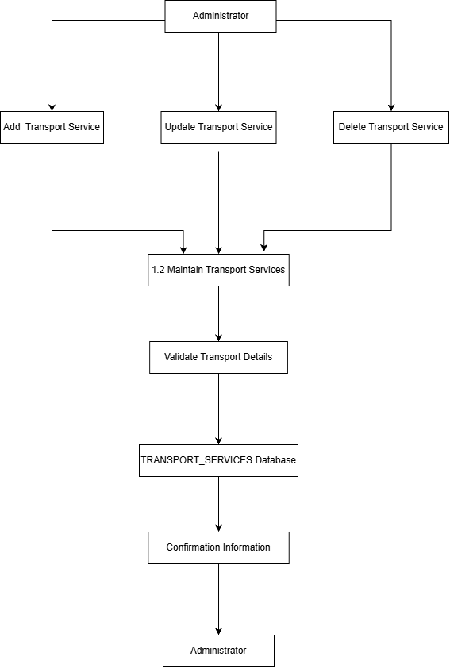

Maintain Tourist Attraction
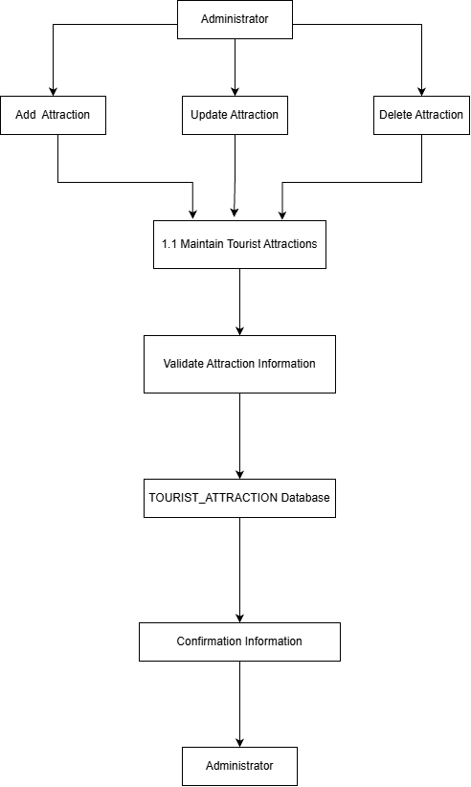

Database Schema
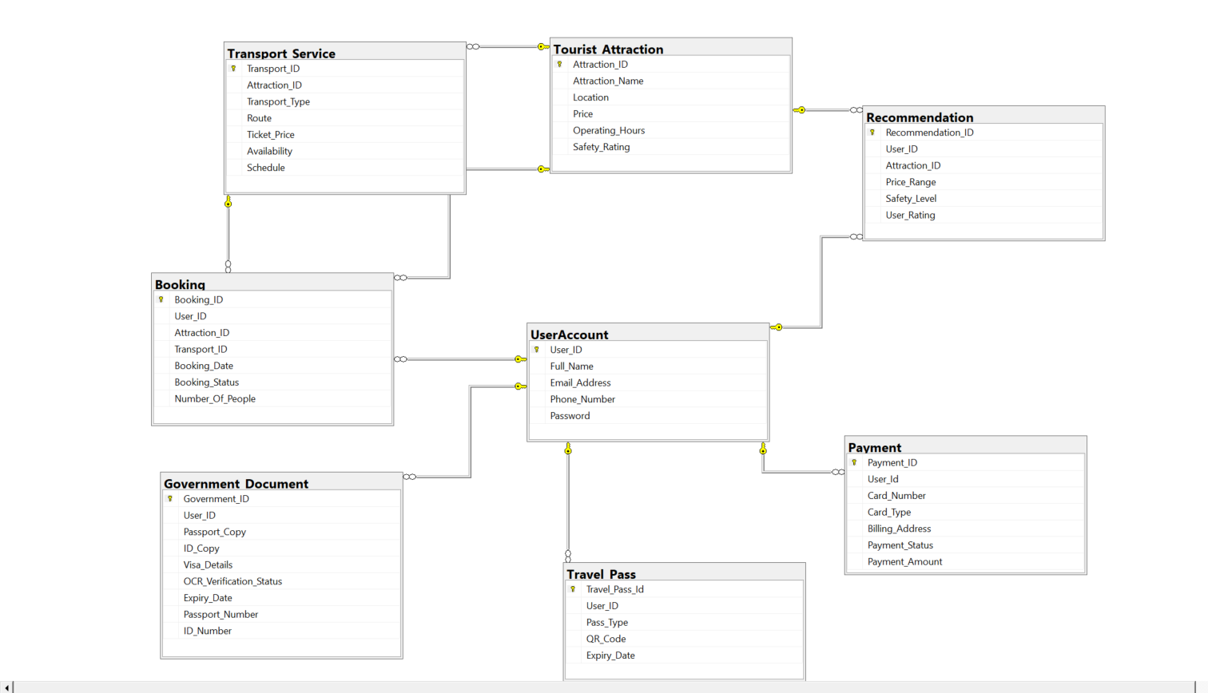

All SQL USED

Creating The Database:
UserAccount:
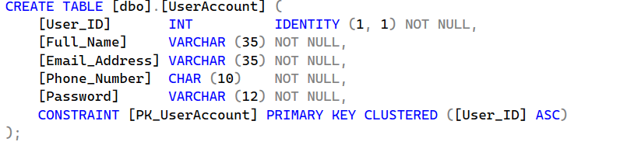

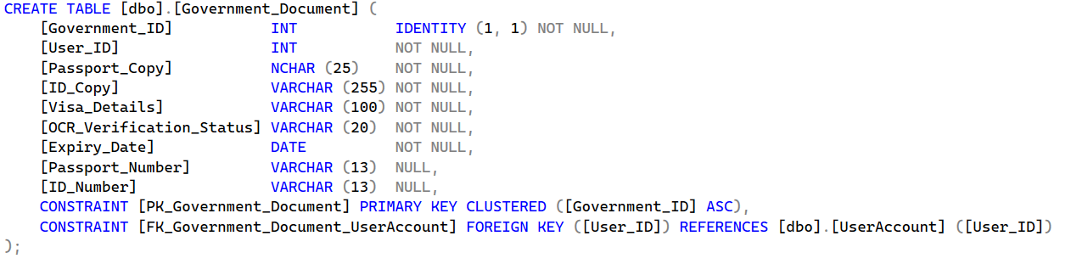
Government Document:
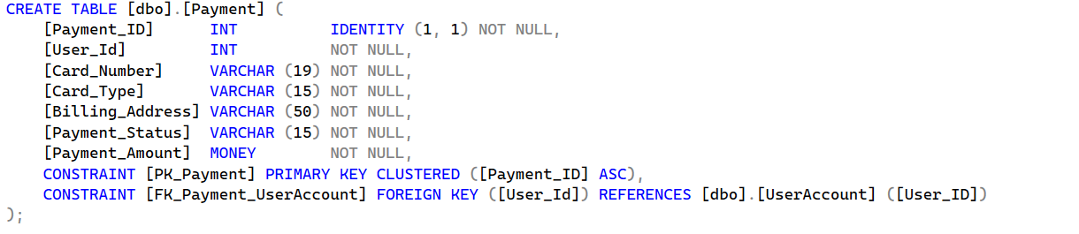
Payment:

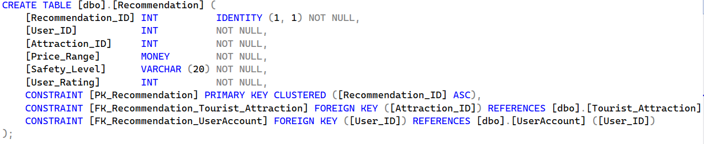
Recommendation:

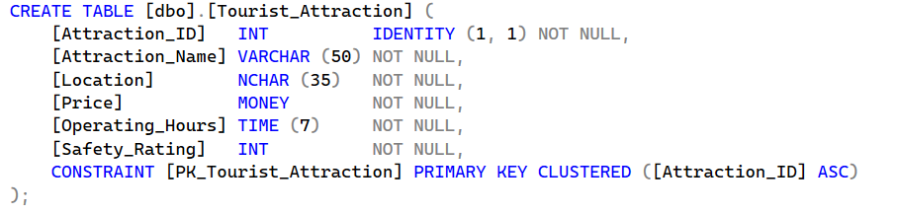
Tourist Attraction:

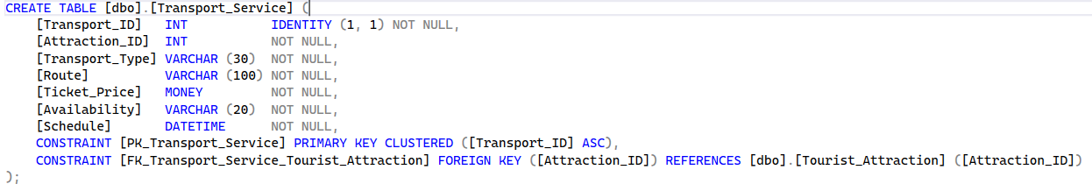
Transport Service:
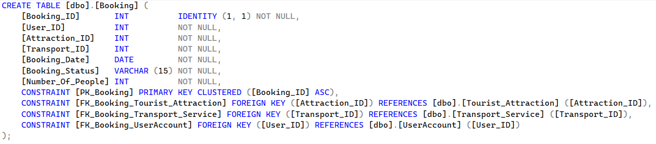
Booking:

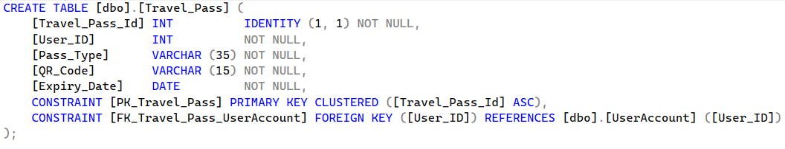
Travel Pass:
Maintaining The Database

Members



